Türk İslâm Medeniyeti Akademik Araştırmalar Dergisi
Journal of the Academic Studies of Turkish-Islamic Civilization
timad
Cilt / Volume: 18 - Sayı / Issue: 35 - Yıl / Year: 2023

One line
ISSN: 1306-4223
e-ISSN: 2822-4612

Four line
Article Title / Bold / The first letter of each word must be capitalized / middle
(10 points)

One line
Türkish Title / Not Bold – İtalic- The first letter of each word must be capitalized
(10 points)

Beş satır boşluk
Author 1*: Name Surname  Title, University or Instution (in English)  Title, University or Instution (in Turkish)  e-posta  orcid.org/…………..(Orcid ID) | Author 2:
If the work has a single author, it will be written centered on the page.

The spacing will be adjusted so that the first page information does not hang over the next page
Makale Bilgisi / Article Information
Makale Türü / Article Types: Derleme (Tez) / Review (Thesis)
Geliş Tarihi / Received: 01.09.2022
Kabul Tarihi / Accepted: 04.01.2022
Cilt / Volume: 16, Sayı / Issue: 32, Sayfa / Pages: 241-256
Atıf / Cite as: (Example) Uysal, M., Navruz Berk G. (2021). Özgün Bir Biçimleniş; Tüteklikli Örtü [An Orijinal Form: Laternen Roof], Türk İslâm Medeniyeti Akademik Araştırmalar Dergisi-Journal of the Academic Studies of Turkish-Islamic Civilization, 16/32: 241-256.
İntihal / Plagiarism: Bu makale, en az iki hakem tarafından incelendi ve intihal içermediği teyit edildi./ This article has been reviewed by at least two referees and scanned via a plagiarism software.
*Sorumlu Yazar/Corresponding Author (birden fazla yazar olması durumunda)
Article Title (Bold-Centered and first letter of each word capitalized)

Abstract
English abstract text (150-200 words)

Keywords: 4-5 words
One line
Turkish Title (bold, Centered and first letter of each word capitalized)

Abstract
Turkish abstract text (150-200 words / It should be the same as the English abstract, checked by the native)

Keywords: 4-5 words
Article text. It is left to the authors to define chapter titles (preferably numbered). If the study will consist of titles and sub-titles;
1. Main Headings (bold and first letters capitalized)
1.1. Subheading (bold and only first word capitalized)
1.2.
It should be numbered and formatted.

The text should be written on A4 paper with a margin of 5.22 cm from the top and bottom, and 4.2 cm from the right and left. This text has been prepared according to this defined format. Articles with this format should not exceed 25 pages.

The font should be Book Antiqua.
TITLE 10 POINT The first letters of each word are capitalized, English Title Initial Letters are Capital (according to English spelling rules)
All other texts are in 10 pt.

Visual material titles 8 points (Figure 1. ….., Table 1……. etc.)
Footnotes should be 8 points. (Footnotes should be defined as sequentially under each page and restart each section. It is preferred not to use footnotes.)

Line spacing should be “single” in all text.

One line spacing should be left before the chapter titles, before and after the visual materials. The indent should be 0.7 in paragraphs, and there should be 6 nk space between paragraphs.

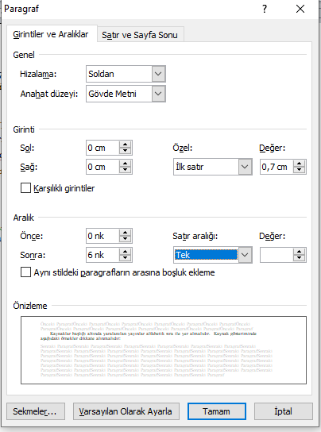

The publications used under the heading of Resources should be listed in alphabetical order. APA format should be used for reference.
1) Direct Citation: Such quotations are taken from the source work as it is. Requires page number. For this, the name of the author and the root of the work must be specified. The quotation must be in quotation marks (“…”). Page range should be given in the source. For example: (Aydın, 2018, p:21-33)
2) Indirect Quotation: Such quotations are made for the idea that the author has mentioned. However, the source is indicated. Does not require quotes (“…”). Page spacing is not required in citation.

Examples:

1) Put the mentioned author(s) and date(s) in parentheses and put them at the end of the sentence or in the appropriate place.
For example: Researchers have shown that the lack of qualified personnel is the biggest obstacle to providing good health education (Fisher, 1999) and services (Weist and Christodulu, 2000).
2) Only the date can be in the parentheses.
For example: Taylor, Keller, and Egan (1997) asked the following question in their research
“………………………………?” (p.28). Since a direct quotation is made here, the page number should also be placed in parentheses.
3) Author name and date can be combined in one sentence
For example: Weist in 2001…………

Some situations can be summarized with the following tables.
Direct Quotations are given in Articles 16, 17 and 18.

The list of references should be created as follows (References should be listed alphabetically):
Web addresses should be listed in the text and given as web 1, web 2…. The web pages used from the reference list should be given in order. Access dates to web pages should be written.
References should be written in alphabetical order, and the first letter of the reference title should be taken into account in studies without authors.
In addition, article display under the title of resources;

Grady, J. S., Her, M., Moreno, G., Perez, C., & Yelinek, J. (2019). Emotions in storybooks: A comparison of storybooks that represent ethnic and racial groups in the United States. Psychology of Popular Media Culture, 8(3), 207–217. https://doi.org/10.1037/ppm0000185
Jerrentrup, A., Mueller, T., Glowalla, U., Herder, M., Henrichs, N., Neubauer, A., & Schaefer, J. R. (2018). Teaching medicine with the help of “Dr. House”. PLoS ONE, 13(3), Article e0193972. https://doi.org/10.1371/journal.pone.0193972
It should be in shape. The image below describes the format in the list of resources.
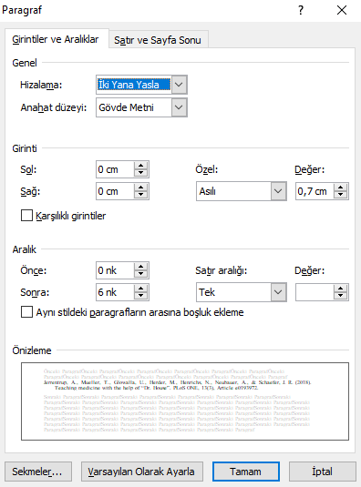

- At the end of the relevant text in the text (Grady and at.al., 2019; Jerrentrup and at al., 2018)
- If the text is started with a reference; According to Grady and at al. (2019) and Jerrentrup at al. (2018), what they stated …… should be structured according to the coming of the sentence.

For other notations not mentioned here : https://apastyle.apa.org/style-grammar-guidelines/references/examples page a should be examined.

Footnotes can be used in the text. Footnotes should be used for explanations, not references. If explanations require the source, they should be shown as in the text. References in footnotes should be placed at the end of the article as defined in the reference list.

Images in the text; It should be in a table. The relevant article should also be included in the table. Table lines should not be visible. As follows:
(Also, if the images were taken from somewhere, the source should be shown.)
Visual texts should be Book Antiqua 8 points.

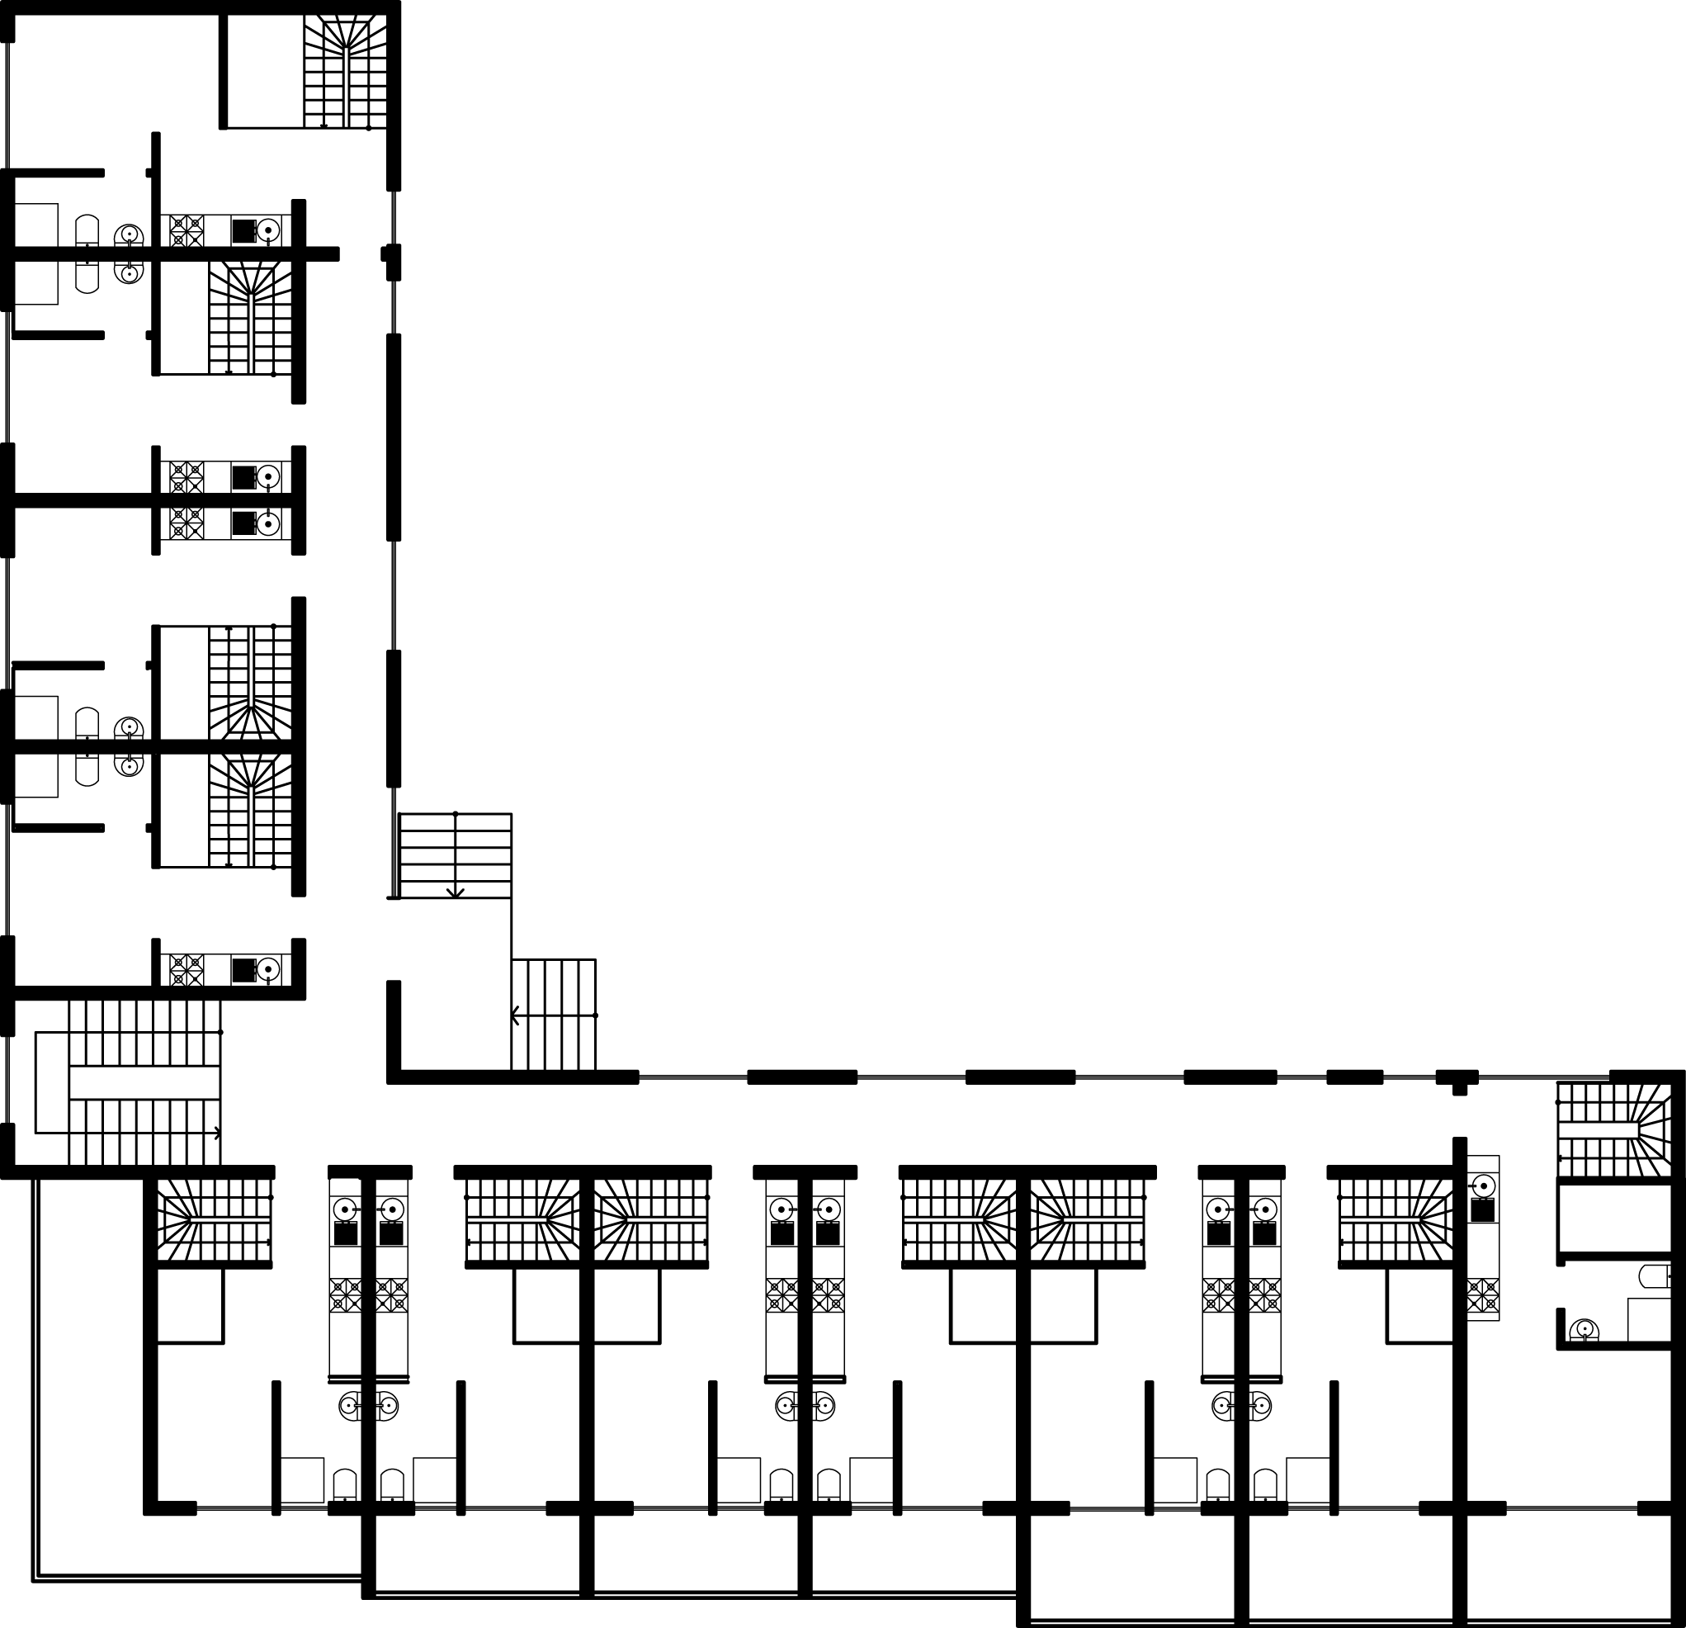 | 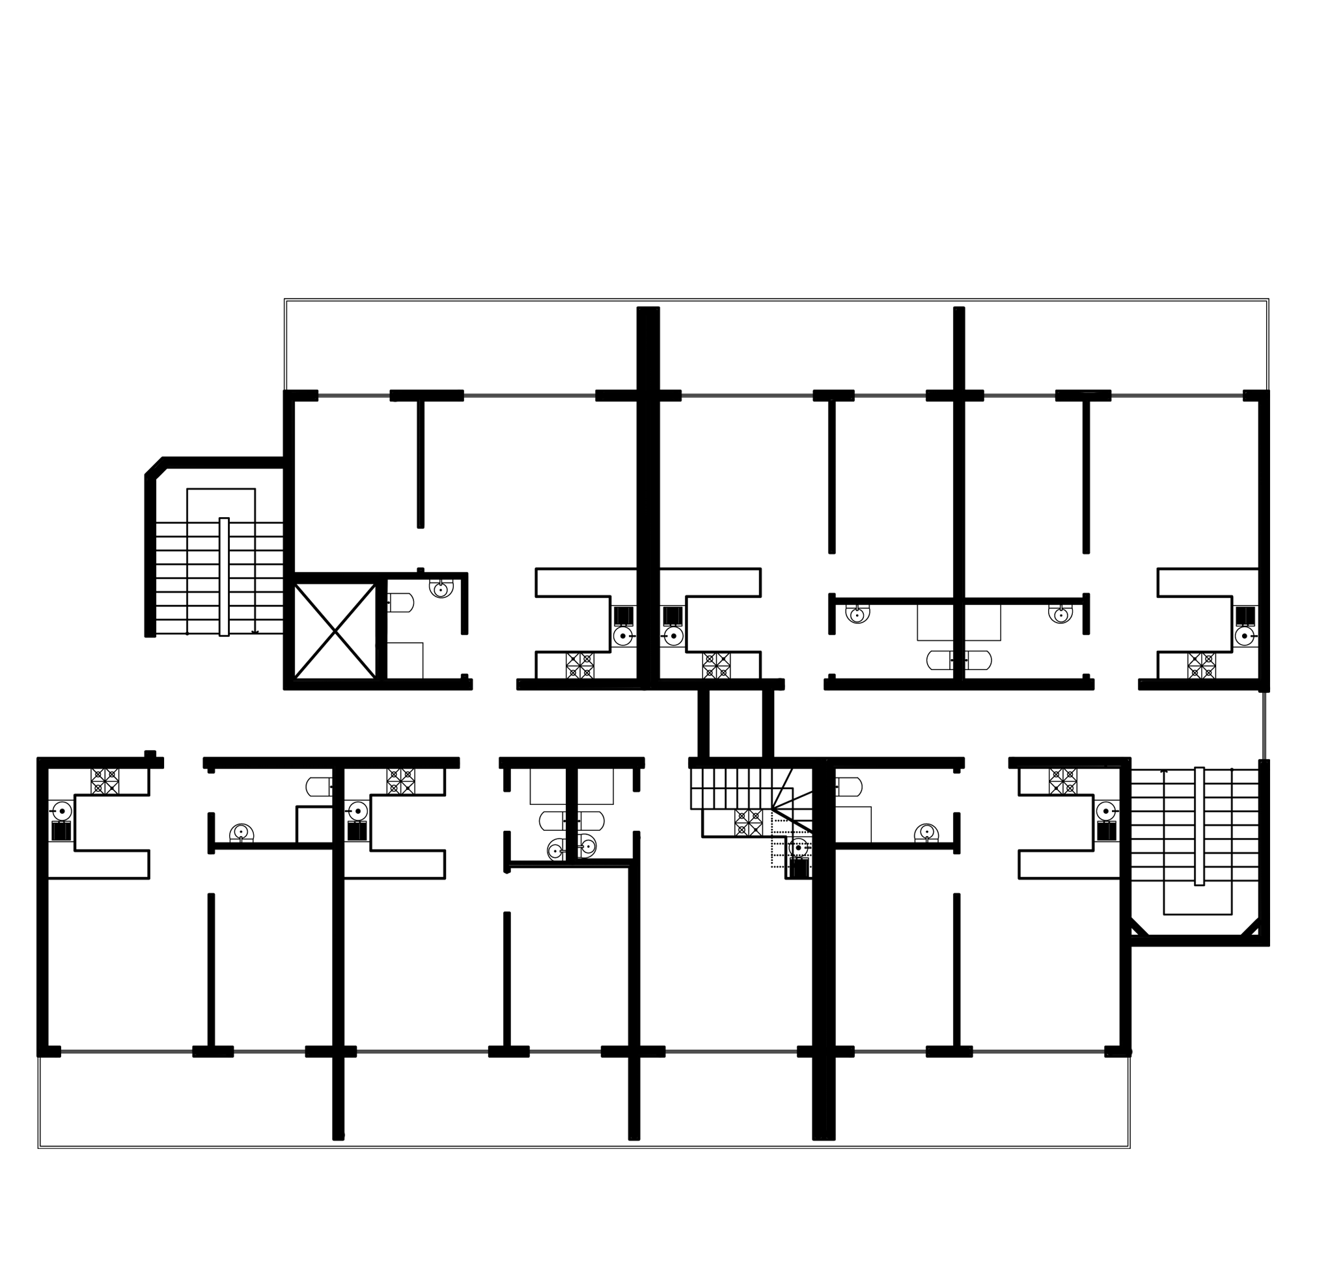
Figure 1. Example 1 Ground floor plan. | Figure 2. Example 2 Ground floor plan.

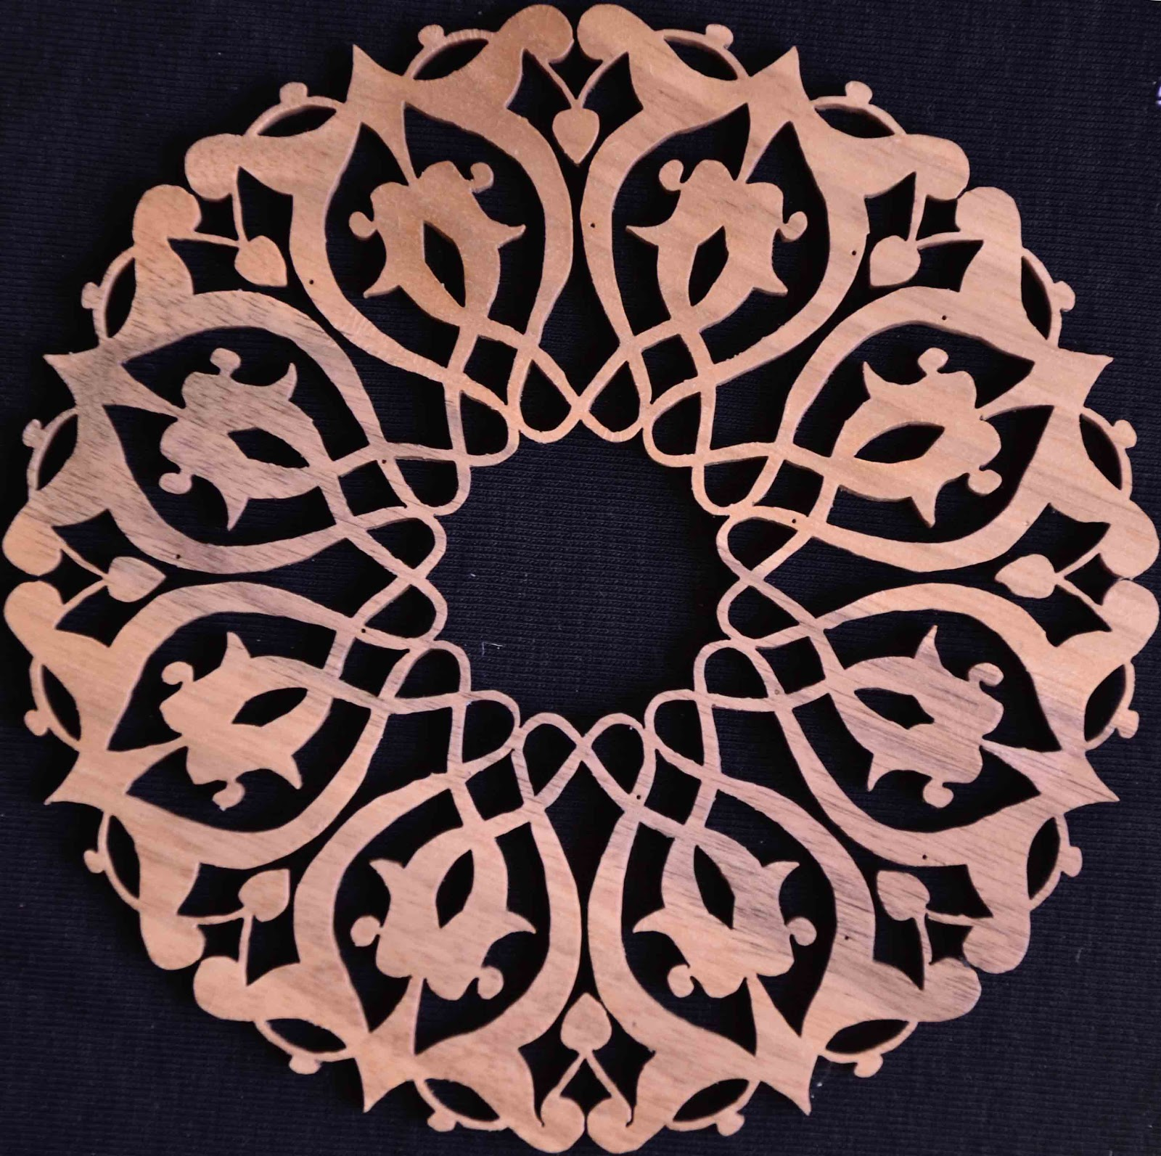
Figure 3. Geometric pattern (Aydın, 2010)
The following image will be helpful for table lines. “No border” will make all gridlines invisible.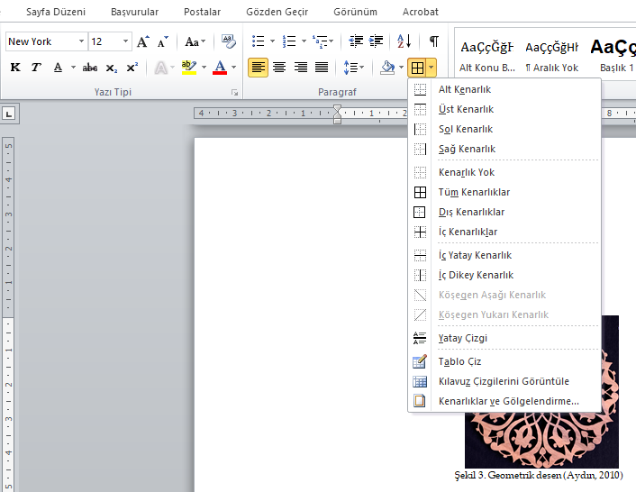

You need to get the ORCID number specifically for the authors. You can get your orcid number by entering this web page (https://www.bilim.org/orcid-bilimsel-arastirmaci-sistemi/). If it has been received before, you must use that number.

